This doc is written very tutorial-esque but there are a bunch of curriculum topics baked in. Just FYI there’s stuff to study in here, not just project setup steps.

What is JDBC?

- JDBC (Java DataBase Connectivity) is a SQL interaction library. We’ll use it to connect our databases to our Java servers.

- We’ll use JDBC to read and manipulate data in the database with Java code.
- Server to DB communication is an integral component of full stack dev!

- There are a couple setup steps to take before you can use JDBC in your projects.
- For starters, we use a Gradle dependency for postgreSQL. So our projects with JDBC will always be Gradle projects.

Setting up JDBC functionality (I tend to make the DB first, then work on the java server)

- Set up the database driver - JDBC is database agnostic! It can work with any database vendor. Thus, we need database drivers to specify what database we’re using (and as you know, we’re using postgres).
- First, specify the database dependency in your build.gradle (Remember, maven)
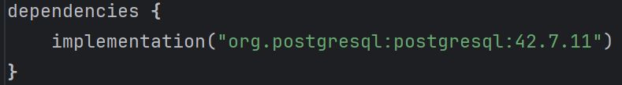
- Create your ConnectionUtil. This Util Class manages Connection objects, which represent a physical connection with a database.
  - The getConnection() method returns a Connection object. Without this, we aren’t able to connect to our database.
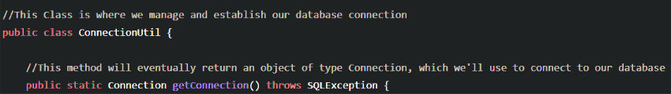
The getConnection() method does 3 things:
- Register your database driver in your application logic
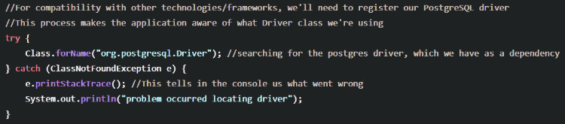
- Open a connection using your database credentials
- Hardcoding your credentials is BAD… see how not to hardcode them below (optional)
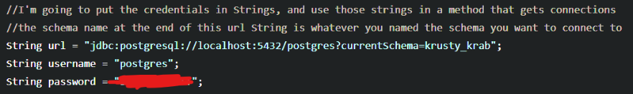

- The DriverManager Class is what makes the DB connection (using the DB driver)

Actually using JDBC

- Remember to understand the Demo to see actual working examples!! This is just a quick reference to the strategies in the curriculum.

- But hey, congratulations! You’re ready to use JDBC to execute some SQL statements in your DAO layer using the following Statement Interfaces and the .executeQuery() method for SELECT, or the .executeUpdate() method for INSERT, UPDATE, and DELETE. See definitions and examples below.

- Statement - “simple statement”, takes a sql string and runs it. Good to use for statements that won’t vary (statements with no parameters).
- 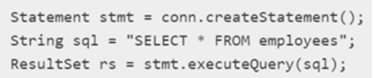
- PreparedStatement - extends Statement, lets you parameterize a sql statement with “?” as the variable, and the .setXXX() methods to fill them with values. This is good for statements that may vary.
- This also protects us from SQL injection by separating the SQL code from unintended user input.
      - SQL Injection? It’s the malicious inclusion of SQL by a hacker looking to delete stuff or access sensitive data.
- 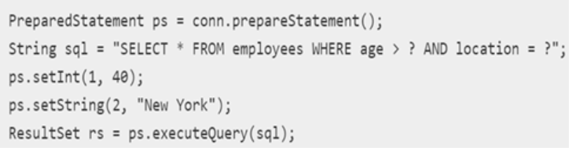

- Results from an SQL query are returned as a ResultSet, which is an Interface that represents a database ResultSet, which is what gets returned when you run select statements. You iterate over a ResultSet to extract the data.
  - Examples in demo!!! But how do we iterate over sequential data? Probably just a for loop :)

What is the DAO layer?
- In our projects with JDBC, you’ll see DAO classes in a DAO package. What is that?

- Bookish Definition: a Data Access Object (DAO) is a pattern that provides a way to send and receive data between an application and a database. By mapping application calls to the persistence layer, the DAO provides some specific data operations without exposing details of the database
- In more plain English: A DAO is simply a class that’s in charge of communicating with your database. That’s where you’ll be putting your statements that send queries to the database to either manipulate or view the data (DML).
- For P0-P1, you’ll be doing DDL in DBeaver, and DML in your JAVA DAO layer

Try with Resources?
- In our DAO layer, you’ll notice try catch blocks that look like this.
- This is a “Try with Resources” block. We open up a resource within parenthesis after the try keyword, before the block of code to try starts. This is very convenient because it CLOSES our resource after it’s done being used! So we don’t have to manually close this Connection object, because the try with resources block will close it for us.
    - This lets us automatically avoid issues like memory leaks, where a resource is consuming memory for no reason, indefinitely.

How Not to Hardcode DB Credentials? ENVIRONMENT VARIABLES
- Putting your credentials in as plain text may be asking for trouble…
- There are bots that trawl github looking for exposed credentials. Scary!

- The easiest way to protect secrets, in my opinion, is to put them in your system environment variables. And then access them with the System.getenv() method
- See the commented flow to get to the environment variables config

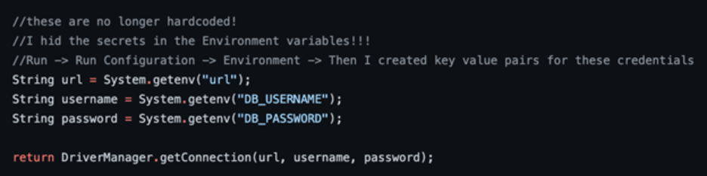

- You can do something similar with a .properties file, feel free to look into that way.

*tutorial on JDBC setup if the above notes don’t quite do it for you. Be warned it’s a little old.
https://www.youtube.com/watch?v=OGP2R29vzAw

